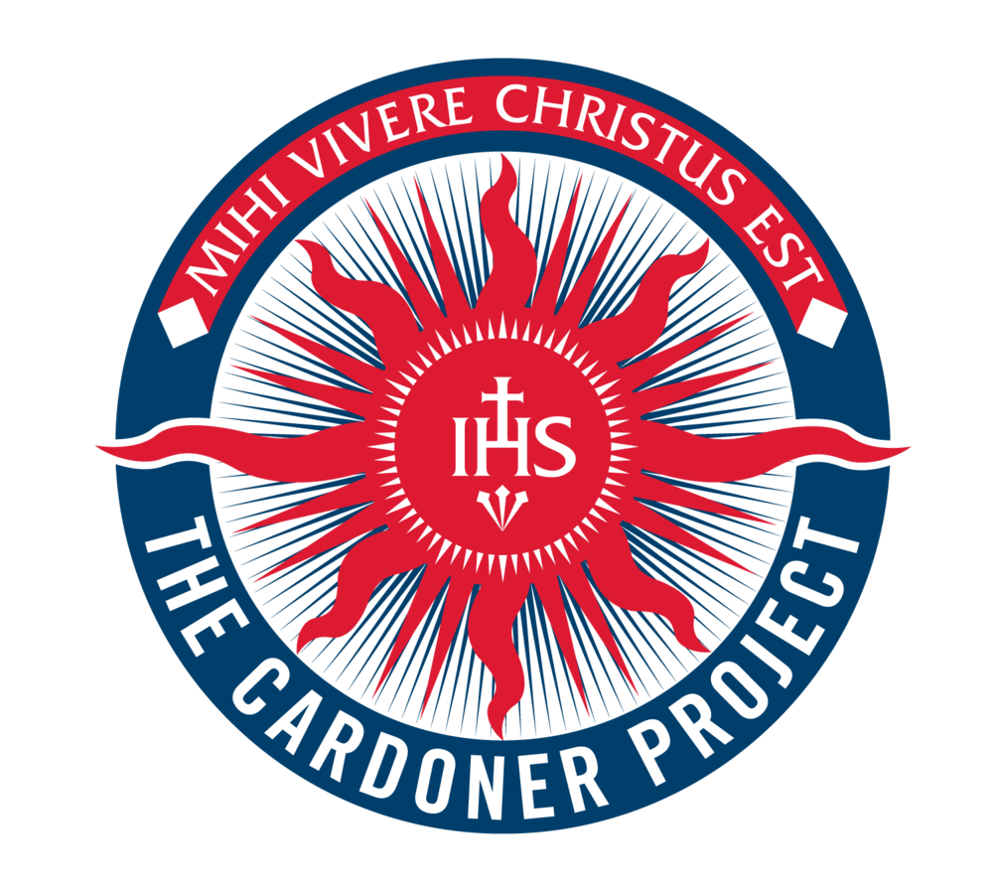

The Cardoner Volunteers Corps
Short Term Service Placements 3- 6 months
Vietnam / Tonga / Zambia

Rationale
The Cardoner Project is an initiative arising from the Australian Jesuits call to mission for “a faith that does justice”. The focus of The Cardoner Project is to support young men and women in their spiritual formation and their ongoing commitment to a life of service. A Service volunteer placement is one of a number of activities that come under this Project.

The 2017 Short term Service is an opportunity for an experience of service and relationship with the poor living for an extended period in a different culture. It is an excellent opportunity for spiritual and human formation, but it is not the best option for everyone. It carries risks and great challenges of which you must be aware before you seek selection for a placement. These risks will be highlighted for you in more detail before your departure, if you are successful in this application process.

Partnerships
It is essential that each applicant discuss this application, selection process and the risks associated with the placement with their parents/guardians.

Role
The Cardoner Project first visited Vietnam in January 2010 and since then we have developed a deep and strong relationship with the sisters and children. In Vietnam, volunteers would be living and working in St Vincent Diem's Centre for Children with Disability. They will care for and feed the children at the centre as well as help assist the sisters with everyday activities; there is also an option to teach the children as well. Volunteers will be billeted in a community in north-eastern Tonga. They will teach in the local schools as well as doing some agricultural work on the local farms .In Zambia volunteers will be working with the diocese of Chipata. They will assist in the teaching of English to the local children and young adults in the school and in the surrounding areas. They may be involved in working in the hospitality school, construction and farming projects. These people that they will be living and working with are socially and economically excluded in many instances. The service volunteer will play an important role in their education and confidence building.

Funding
You will be responsible for your own travel insurance, visas and costs associate with obtaining a visa.

You will need to pay $3,000 for your 3 month’s to cover your food, accommodation and other related costs. You will live in a volunteer community house under the direct care and supervision of our partner project managers. The rooms are basic and may be shared. Food will be more than sufficient but will be in keeping with the local fare.

During your stay overseas, Sue Walsh, as Manager of Immersions and Service Year or Cathy Hammond her Assistant, will be in contact with you regularly. They will be available for contact via e-mail and/or Skype. Internet is rarely available some in the villages. You are, of course, encouraged to maintain very regular contact with your family in Sydney.

If more serious or urgent medical care is needed then you must ensure that you have sufficient Medical and Travel Insurance to cover all serious accidents and illnesses. This is your responsibility to arrange. If you need to be repatriated to Australia for medical care then your Insurer must arrange this, as your parents and they deem appropriate. Your Insurer will need to approve any medical and hospital expenses. We are able to provide insurance for $80 however; this wouldn’t cover you for riding mopeds.

Risks
There are risks associated with volunteering in Vietnam and Zambia. You must seek professional medical advice as to what is required for you to prevent infectious diseases and other health problems. The Cardoner Project does not offer you medical advice. You must be sure to avoid behaviours that might endanger you unnecessarily.

If you wish to ride or drive vehicles in any of the destinations then you must satisfy the requirements of your Insurer to ensure coverage for this activity in case of an accident. It is your responsibility to ensure that you meet your Policy requirements.

Selection Process
This Cardoner Volunteer Corps Service Application Form, is a means to assist you and the Selection Committee in making a decision. Good spiritual discernment always involves the dual focus on the needs of the individual and the needs of the mission with the latter always primarily orienting the final decision. This application does not guarantee your selection.

Please take some time from your busy schedule to fill out these following pages with care and return them to Suzanne Walsh by email to sue.walsh@thecardonerproject.org as soon as possible to be considered for a service placement.

Name of Applicant: Placement of choice:

Length of Placement: 3 Months (Circle correct time period)
6 Months

Date of Birth:

Contact telephone number:

Contact email:

Parent or Guardian’s telephone number:

Parent or Guardian’s email:

Question 1) St. Ignatius believed that God relates ‘directly with the creature’ through the ‘holy desires’ of our hearts. What is your desire for your Year of Service? In other words, why do you want to live and work with the poor? What is it that you hope this time might be able give to you?

Question 2) This placement will require of you a great deal of resourcefulness, innovation, adaptability and leadership. To offer these things to others requires also a habit of honest self-reflection and knowledge of one’s limitations as well as strengths. What gifts and abilities will you bring to the Year of Service? What are the limitations that you identify in yourself that may restrict your possible contribution?

Question 3) This volunteering opportunity will require you to live in a somewhat remote place with one or two other alumni. You will need to work and live together without many, if any, other English-speaking co-workers. This means that you must be able to not only get on well with each other but also know how to disagree at times, and yet, maintain the relationship. How would you say you are at getting along with other people who perhaps do not always agree with you? Try to be as honest as you can be in this self-assessment. Give one recent example of how you dealt with a conflict with a school peer? Were you happy with the way you handled this conflict? What might you have done differently in hindsight?

Question 4) This volunteering opportunity will test your ability to live without the usual emotional and psychological resources in your life. While you can sometimes telephone, email and Skype with family and friends back home you will not have them nearby when things get difficult or when you experience homesickness. You will need to draw on your capacities for resilience to a high degree. How would you assess your resilience in the face of setbacks and challenges? Give one recent example of a setback in any area of your life and describe how you responded to it? If you were particularly hurt or down as a result of the event what were some of the ways you managed to get on with things afterwards? Looking back, or, at the time, were you aware of how your mood was affecting your behaviour?

Question 5) Central to the lives of the villagers whom you will serve will be their faith. Are you comfortable with this level of religious observance? Do you see it as an opportunity for spiritual growth or a hindrance to it? How would you describe your faith life at the moment? How would you like to see your faith develop during this volunteering period?

Question 6) This experience of living and working as a volunteer to the poor will be life changing. How do you envisage taking this experience with you for the rest of your life? What do you hope to do as a career? Are you open to this experience changing your perspectives on and plans for your whole life?

Question 7) Living and working as a volunteer in remote parts of Cambodia involves a number of clear risks to your health and wellbeing. Have you discussed these risks with a medical health professional? Are you willing to accept these risks and act in a manner that does not place you in situations of unacceptable risk?

This part of the Application Form is optional for a parent(s) or guardian(s) to complete.
Please return to Suzanne Walsh by email sue.walsh@thecardonerproject.org by 30th May, 2017.

Name of Applicant: ________________________________

Contact telephone number: _____________________________

Contact email: ________________________________________

Parent or Guardian’s telephone number: _____________________

Parent or Guardian’s email: _______________________________

Question 1) The placement for which your son is applying is a difficult one with many challenges and risks. What do you hope he receives from the experience? What are your hopes for him/her? What are the anxieties and fears you have for him/her?

Question 2) You know your son/daughter better than the Selection Committee can or do. What do you see as his/her gifts that he/she will bring to this Year of Service? At the same time, what are some of his/her limitations?

Question 3) Is there anything else you would like to write about your son’s/daughter’s application?

Name of Parent/Guardian _________________________________

Signature of Parent/Guardian: ________________________________

Date:

